http://www.mirrorsemi.com/CAD.html
https://www.newswire.com/news/cad-design-software-introduces-four-new-electronics-packaging-designer-21342191
EPD for Windows Suites

Linkcad

autocad lead frame package
http://www.artwork.com/index.html

woocommerce product table
https://rextheme.com/vivino-product-feed-woocommerce/
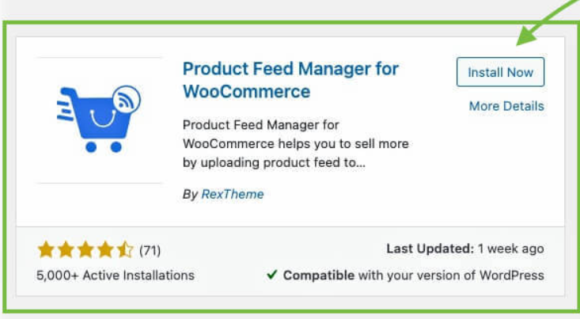
https://stackoverflow.com/questions/47588064/adding-custom-attribute-to-woocommerce-shop-loop-product-title

https://wordpress.org/plugins/tags/brewery/
special filed ABV
https://wordpress.com/plugins/beerxml-shortcode

- Special fields for ABV, OG, IBU, untappd URL, video, and image gallery.

ABV Alcool By Volume
IBU

//////////////////////////////////////////////////////
Husky products filter

https://www.youtube.com/@realmag777/videos

https://products-filter.com/woof_clear_all_text
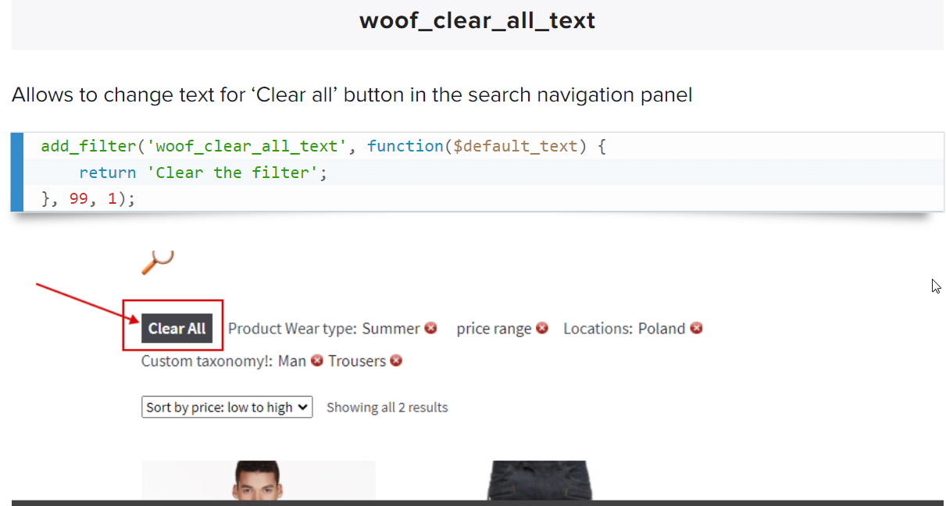

woof_lang.pricerange = “Price”

add_filter( 'gettext', 'rename_add_to_cart_button', 10, 3 );
function rename_add_to_cart_button( $translated_text, $text, $domain ) {
if ( $text === 'Words That I want to Translate' && $domain === 'woocommerce' ) {
$translated_text = __( 'My Own Translated Words', $domain );
}
return $translated_text;
}

https://stackoverflow.com/questions/27259838/change-or-translate-specific-texts-in-woocommerce

